MED D - Test Claim - Calculating Quantity of Bulk Powders

Definition | A pharmaceutical powder is defined as a dry, solid substance, composed of finely divided drugs with or without excipients and intended for internal or external use. It is a solid substance in finely divided state typically obtained by crushing, grinding, or comminuting.  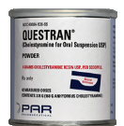
Instructions for Running a Test Claim | How many scoops does the beneficiary use each day?  What day-supply is needed?
Additional Notes | We are unable to perform price estimates for compound containing powder ingredients. Refer to Handling Compound Calls - Care.
What if Test Claim Rejects | Review the rejection code to determine what caused the rejection. Once the rejection code is identified, access the proper work instruction and job aids in theSource to help you resolve the issue.

Example
Questran Powder Can

Directions: Use 3 scoops daily for 90 days
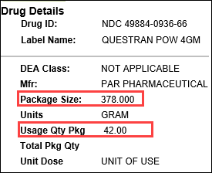 |  |  | 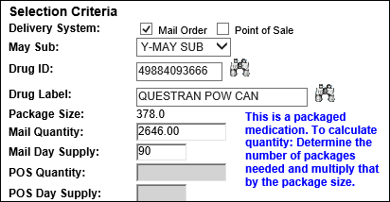
Calculation
Scoop per Day | X | Days |  | = | Scoops Needed
3 | X | 90 |  | = | 270
Scoops Needed | ÷ | Usage Quantity Package  (from PeopleSafe) |  | = | Total Number of Cans
270 | ÷ | 42 |  | = | 6.42 (Round up to 7)
Total Number of Cans | X | Package Size  (from PeopleSafe) |  | = | Test Claim Quantity
7 | X | 378 |  | = | 2646

Example
Questran Powder Packets

Directions: Mix 1 packet in liquid and drink 3 times a day for 90 days
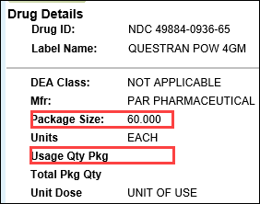 |  |  | 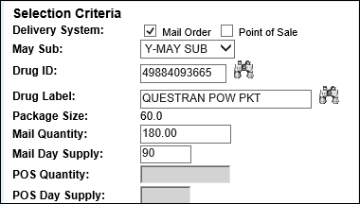
Calculation
Packets per Day | X | Days |  | = | Test Claim Quantity
3 | X | 90 |  | = | 180

Top of the Document

Related Documents
MED D - Test Claim Index
Calculating Quantities for Packaged Medication

Parent SOP: CALL-0049: Customer Care Internal and External Call Handling
Abbreviations / Definitions: Customer Care Abbreviations, Definitions, and Terms

Top of the Document

Not To Be Reproduced Or Disclosed to Others Without Prior Written Approval
ELECTRONIC DATA = OFFICIAL VERSION – PAPER COPY – INFORMATIONAL ONLY

